The Great Apostasy Quotes

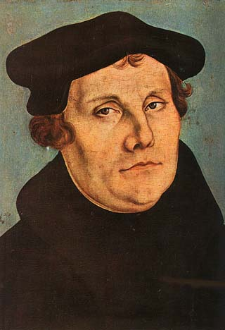
Martin Luther (1483-1546)
“I have sought nothing beyond reforming the Church in conformity with the Holy Scriptures. The spiritual powers have been not only corrupted by sin, but absolutely destroyed; so that there is now nothing in them but a depraved reason and a will that is the enemy and opponent of God. I simply say that Christianity has ceased to exist among those who should have preserved it." In Galat. (1535) Weins IX, P.I. 293, 24-27, p. 50, Luther and his Times, p. 509, Martin Luther, p.188.

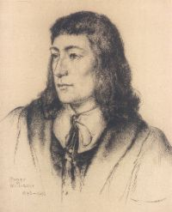
Roger Williams (1603-1684)
Pastor of the oldest Baptist Church in America at Providence, Rhode Island, refused to continue as pastor on the grounds "There is no regularly constituted church on earth, nor any person authorized to administer any church ordinance; nor can there be until new apostles are sent by the Great Head of the Church for whose coming I am seeking." (Picturesque America, or the Land We Live In, ed. William Cullen Bryant, New York: D. Appleton and Co., 1872, vol. 1, p. 502.)

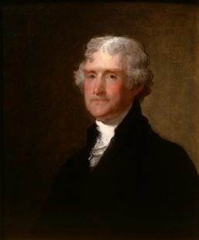
Thomas Jefferson (1743-1826)
"The religion builders have so distorted the doctrines of Jesus, so muffled them in mysticisms, fancies and falsehoods, have caricatured them into forms so inconceivable, as to shock reasonable thinkers. . . . Happy in the prospect of a restoration of primitive Christianity, I must leave to younger persons to encounter and lop off the false branches which have been engrafted into it by the mythologists of the middle and modern ages." Jefferson's Complete Works, vol. 7. pp. 210 and 257
The Great Apostasy Quotes

Martin Luther (1483-1546)
“I have sought nothing beyond reforming the Church in conformity with the Holy Scriptures. The spiritual powers have been not only corrupted by sin, but absolutely destroyed; so that there is now nothing in them but a depraved reason and a will that is the enemy and opponent of God. I simply say that Christianity has ceased to exist among those who should have preserved it." In Galat. (1535) Weins IX, P.I. 293, 24-27, p. 50, Luther and his Times, p. 509, Martin Luther, p.188.

Roger Williams (1603-1684)
Pastor of the oldest Baptist Church in America at Providence, Rhode Island, refused to continue as pastor on the grounds "There is no regularly constituted church on earth, nor any person authorized to administer any church ordinance; nor can there be until new apostles are sent by the Great Head of the Church for whose coming I am seeking." (Picturesque America, or the Land We Live In, ed. William Cullen Bryant, New York: D. Appleton and Co., 1872, vol. 1, p. 502.)

Thomas Jefferson (1743-1826)
"The religion builders have so distorted the doctrines of Jesus, so muffled them in mysticisms, fancies and falsehoods, have caricatured them into forms so inconceivable, as to shock reasonable thinkers. . . . Happy in the prospect of a restoration of primitive Christianity, I must leave to younger persons to encounter and lop off the false branches which have been engrafted into it by the mythologists of the middle and modern ages." Jefferson's Complete Works, vol. 7. pp. 210 and 257
The Great Apostasy Quotes

Martin Luther (1483-1546)
“I have sought nothing beyond reforming the Church in conformity with the Holy Scriptures. The spiritual powers have been not only corrupted by sin, but absolutely destroyed; so that there is now nothing in them but a depraved reason and a will that is the enemy and opponent of God. I simply say that Christianity has ceased to exist among those who should have preserved it." In Galat. (1535) Weins IX, P.I. 293, 24-27, p. 50, Luther and his Times, p. 509, Martin Luther, p.188.

Roger Williams (1603-1684)
Pastor of the oldest Baptist Church in America at Providence, Rhode Island, refused to continue as pastor on the grounds "There is no regularly constituted church on earth, nor any person authorized to administer any church ordinance; nor can there be until new apostles are sent by the Great Head of the Church for whose coming I am seeking." (Picturesque America, or the Land We Live In, ed. William Cullen Bryant, New York: D. Appleton and Co., 1872, vol. 1, p. 502.)

Thomas Jefferson (1743-1826)
"The religion builders have so distorted the doctrines of Jesus, so muffled them in mysticisms, fancies and falsehoods, have caricatured them into forms so inconceivable, as to shock reasonable thinkers. . . . Happy in the prospect of a restoration of primitive Christianity, I must leave to younger persons to encounter and lop off the false branches which have been engrafted into it by the mythologists of the middle and modern ages." Jefferson's Complete Works, vol. 7. pp. 210 and 257
